
KOREAN TIGERS TAE KWON DO
(www.choskoreantigers.com)

Courtesy
Integrity
Perseverance
Self-Control
Indomitable Sprit

Program : Tae Kwan Do, Hap Ki Do, Cardio Kickboxing

At : 2400 Satellite Bldv Ste 102 Duluth, GA 30096

Tel : 678-584-0737

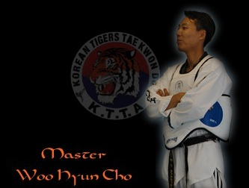
Master Cho has been involved with the martial arts most of his life.
Born in Seoul, Korea in 1970, he began his training at
7 years old. He later attended Yongin University in
Seoul where he received his bachelors degree in
Physical education and martial arts. After serving in the
Military and completing college, Master Cho traveled
The world as a trainer and team member of the
Korean Tigers Professional Demonstration Team.
He came to the United States in 1996, teaching
In Utah until he moved to the Atlanta area in 1997.
Master Cho has Master level certifications in both
Tae Kwon Do(5th Dan) and Hap Ki Do(4th Dan).
He and his fiancée Anna opened the school in May 1999.

